**Mood boards in design**

Because of their ability to combine abstract concepts such as emotions, desires, and thoughts, professionals from all creative fields use mood boards as a powerful tool for visualizing ideas and concepts.

**What exactly is a mood board?**

Mood boards are graphic panels that combine different sensory sources to create a dynamic environment that acts as a guide for creative decisions. Photos, colors, illustrations, animations, fonts and textures can be used to develop a mood board that explains the emotions you want to arouse in users while also merging the creative vision of the design.

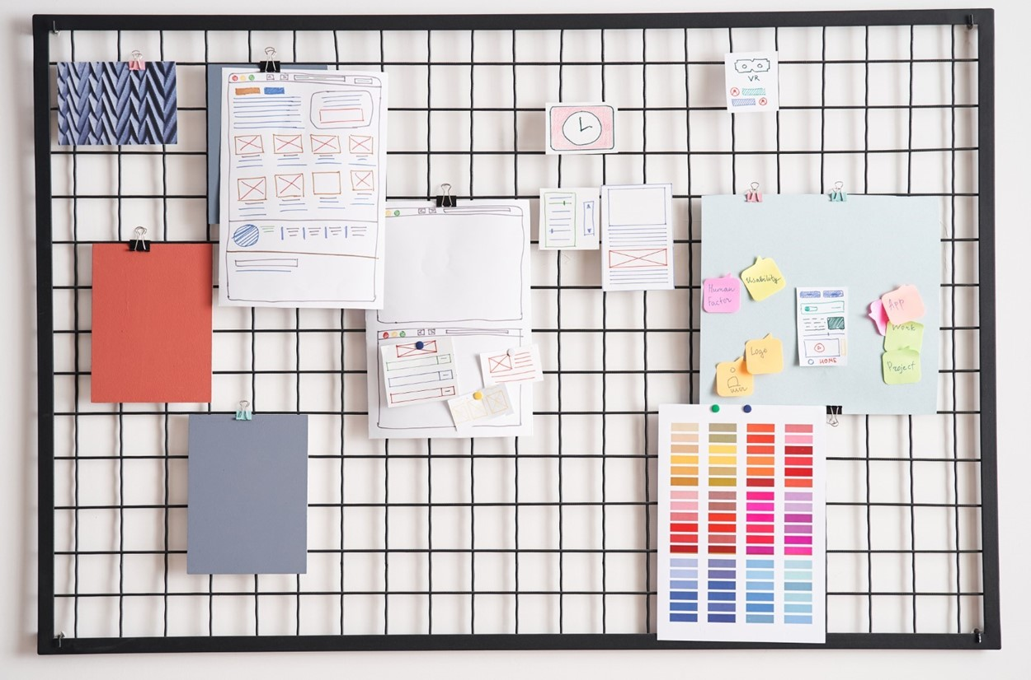

**What is the purpose of a mood board?**

These panels are used to imaginatively connect ideas, bringing together the vision of stakeholders, users, and the design team. They serve as a centralized asset source that the team can access anytime. Mood boards can be used for the following:

**Documentation of research**

Mood boards can be used for a variety of research tasks, such as benchmarking research, persona definition and user interface ideation.

**Designer exploration and guidance**

A mood board is a space where designers can freely explore their ideas without judgment at the start of a project. When a board is finished, it serves as a resource for the team throughout the project.

**Combining visions**

The idea is, by definition, abstract and one of the most important functions of a digital or physical mood board is to outline thoughts. Different stakeholders can contribute their visions and reach come to an agreement, giving everyone more strength in the project's direction.

**Types of mood boards**

They can be physical or digital, and each has its benefits: Digital boards are easier to put together, format and accept natively digital references like animations and GIFs or graphics interchange format, which is a digital file format. Physical boards require more effort to format and can be shown or displayed in physical environments such as a working space's wall. In the physical version, you can dig deeper into objects like paints, fabrics, papers, metals, perfumes and organic materials like plants. Some elements, such as those associated with touch or smell, lose meaning when reproduced digitally. Digital boards, on the other hand, can use their native environment to collect massive amounts of data.

**Creating a mood board**

There are numerous techniques for creating mood boards, and it is critical to understand which one is best suited to your project and creative team. A digital board is recommended in web or app design projects so that you can collect references from animations, micro-interactions and typography. However, having a physical board in the office can be a constant reminder to everyone who sees it. To create compelling and user-centered mood boards, follow these steps:

**Recognize the goal**

Choose the main path in your design before you begin collecting puzzle pieces. Make a clear statement stating which emotion should be triggered in a persona when they make contact with your solution:

"Tilly must be motivated to order food when she browses our website."

**Set the tone**

Setting the tone of the brand aids in creating an effective mood board. Choose some keywords that represent the team's vision as a simple exercise. The tone words can be saved to the board, so they are always available to everyone. Keywords are words like "fresh, "Mediterranean," and "traditional" in the Little Lemon example.

**Collect information on the subject**

Before looking for visual references, do more research on the subject. Take notes during meetings, and collect data from users and user interviews to gather information for the project.

**Establish your values**

Set clear values from the start when creating a mood board, such as modern, fun, childish, colorful or sporty. Define three or four adjectives for your board to help with reference selection.

**Think big first, then small**

Begin by defining large groups within the central theme and then delve deeper into each to organize the discovery process. One method is to divide your mood board into smaller ones based on similar patterns and remove the outliers.

**Choose wisely**

Don't just stick anything on your mood board. Choose only items that will have an impact on the project's direction. If you have two or more pieces that are very similar, choose only one to represent that idea.

**Final thoughts**

Aside from being enjoyable and collaborative, the process of creating mood boards serves to unite professionals and stakeholders by putting individualities aside and focusing on a shared vision of success., resulting in a final product that is aligned from the beginning to the final design of the interface.